**Practical 4**

**TASK:**

**Study and Installation of Mongodb on Local Machine.**

**Study of “Cloud Platform- MongoDB Atlas”**

**Installation steps of MongoDb**

Step-1 Download MongoDB from following link https://www.mongodb.com/try/download/community Step-2 Start installing setup by clicking on Next

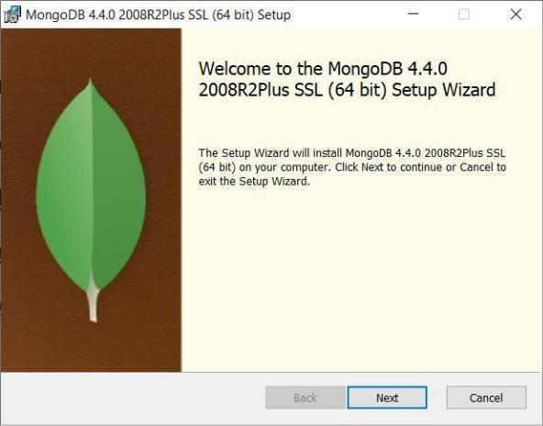

Step-3 Accept terms in license agreement and click on Next

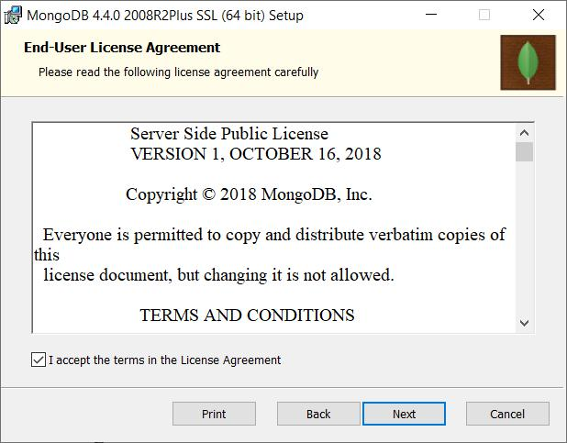

Step-4 Click on Complete

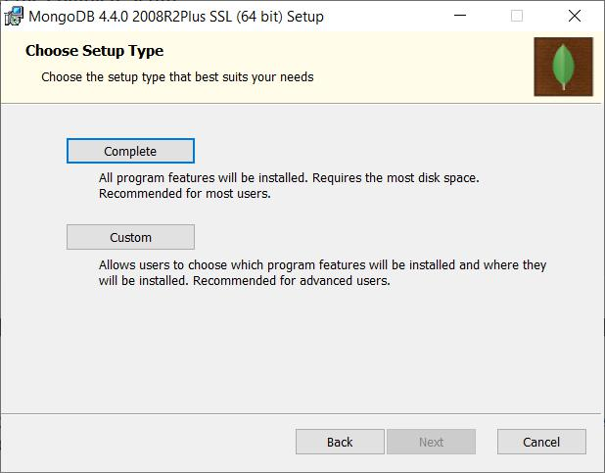

Step-5 Select “Run service as Network Service user”

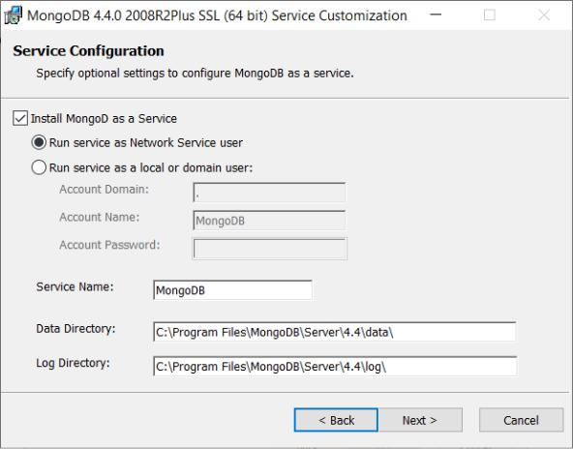

Step-6 Deselect Install MongoDb Compass and click on Next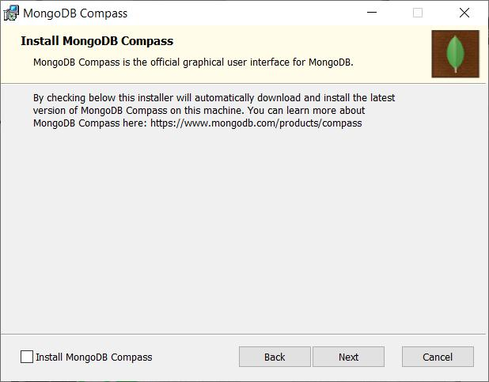

Step-7 Click on Install

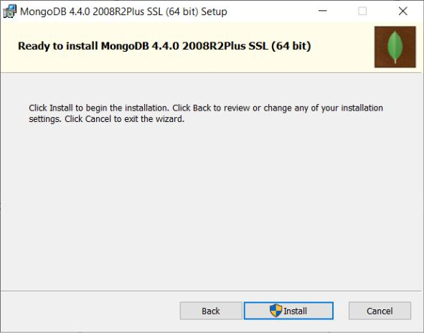

Step-8 Click on Finish

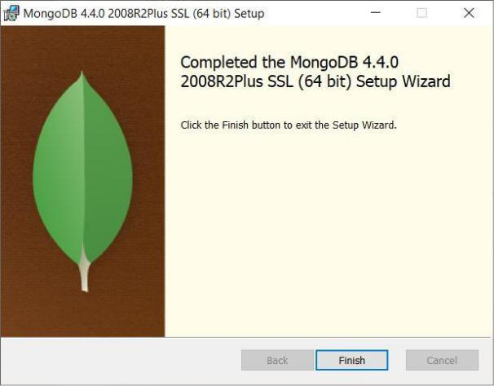

**Write the answers:**

* **What is CLOUD DATABASE? And Benefits of Using cloud Database.**

A cloud database is a database service built and accessed through a cloud platform. It serves many of the same functions as a traditional database with the added flexibility of cloud computing. Users install software on a cloud infrastructure to implement the database.

**Key features:**

A database service built and accessed through a cloud platform

Enables enterprise users to host databases without buying dedicated hardware

Can be managed by the user or offered as a service and managed by a provider

Can support relational databases (including MySQL and PostgreSQL) and NoSQL databases (including MongoDB and Apache CouchDB)

Accessed through a web interface or vendor-provided API

**Benefits of Using cloud Database:**

Scalability: One of the key features of cloud-hosted databases, scalability lets you adjust your operations upwards or downwards as your IT requirements change. Scaling can be done quickly, cheaply, and efficiently, so even small businesses can find value in using the cloud.

Location Independence: Free yourself of the ball and chain! No physical limitations related to server location and storage means that wherever the end user may be, the database is right there, too. Data storage can now be done in an independent location, allowing easy access to information from every corner of the globe. All that readily available data means simpler than ever collaboration, as users can easily access, view and modify shared files.

Lighter Administrative Burden: Cloud-hosted databases don’t eliminate the role of a database administrator, but it can get rid of many features that typically consume a DBA’s time, allowing them to focus on more important tasks.

* **Write about the key-features of Mongodb Atlas**

It's the most popular NoSQL database, has an open-source code base, and offers many useful features such as horizontal scalability.

**Key-features:**

Strong Security Measures

Access control.

VPC peering.

IP whitelists.

Data encryption in transit.

Data encryption at rest.

Field-level encryption.

**TASK:**

* 1. **Study the use cases of MongoDB (ANY2)**

1. Customer Analytics

Creating consistently good customer experiences has become a key challenge for many organizations. The reality is that our expectations around what a good customer experience is has increased dramatically over the past few years. What used to be cool and different is now the norm.

Data aggregation is one of the keys to creating amazing customer experiences. Companies are collecting massive amounts of data about their existing and potential customers and aggregating it with publicly available data. This data can tell companies how customers interact with products (digitally and in person), personal preferences, demographics, etc. From all of this disparate data, companies can build customer profiles and nurture paths with the goal of getting the customer to buy more products.

With all of this data coming from different sources with different schemas, tying it all together at such a massive scale is a huge challenge. The flexibility and scalability of MongoDB provides a solution. MongoDB allows for the aggregation of this data and building analytical tools in order to create amazing customer experiences. MongoDB’s speed allows for dynamic experiences that can evolve based upon the customer behavior in real time.

1. Product Catalog

Product catalogs are not new to the evolving digital experience. What is new is the volume and richness of the data that feeds the interactions in product catalogs that we use today. MongoDB provides a great tool to store many different types of objects with different sets of attributes. MongoDB’s dynamic schema capability allows for product documents to only contain attributes that are relevant to that product. Gone are the days of needing every product record to contain every possible attribute. MongoDB users can very quickly and easily make changes to their catalogs, providing a better experience for developers and customers.

* 1. **Study of JSON vs BSON and brief your understanding.**

|  |  |  |  |  |  |
| --- | --- | --- | --- | --- | --- |
|  |  |  | |  |  |
| **The basis Of** |  | **JSON** | |  | **BSON** |
| **Comparison** |  |  |  |  |  |
|  |  |  | |  |  |
| **Type** |  | Standard file format | |  | Binary file format |
|  |  |  | | |  |
| **Speed** |  | Comparatively less fast | | | Faster |
|  |  |  | | |  |
| **Space** |  | Consumes comparatively less space. | | | More space is consumed. |
|  |  |  | | |  |
| **Usage** |  | Transmission of data. | | | Storage of data. |
|  |  |  | |  |  |
| **Encoding and** |  | No such technique. | |  | Faster encoding and decoding technique. |
| **Decoding** |  |  |  |  |  |
| **technique** |  |  |  |  |  |
|  |  |  |  |  |  |
| **Characteristics** |  | Key | value pair | only used for | Lightweight, fast and traversable. |
|  |  | transmission of data. | | |  |
|  |  |  | | |  |
| **Structure** |  | Language independent format used | | | Binary JSON which consist of a list of ordered |
|  |  | for | asynchronous | server browser | elements containing a field name, type, and a value. |
|  |  | communication. | |  | Field name types are typically a string. |
|  |  |  | | |  |
| **Traversal** |  | JSON doesn’t skip rather skims | | | BSON on the other hand just indexes on the relevant |
|  |  | through all the content. | | | content and skips all the content which does not have |
|  |  |  |  |  | to be in use. |
|  |  |  | | |  |
| **Parse** |  | JSON formats need not be parsed as | | | BSON, on the other hand, needs to be parsed as they |
|  |  | they are in a human readable format | | | are easy for machines to parse and generate. |
|  |  | already. | |  |  |
|  |  |  | | |  |
| **Creation type** |  | Broadly JSON consists of object and | | | The binary encoding technique consists of additional |
|  |  | array where the object is a collection | | | information such as lengths of strings and the object |
|  |  | of key-value pairs and the array is | | | subtypes. Moreover, BinData and Date data types |
|  |  | ordered list of values. | | | are the data types which are not supported in JSON. |
|  |  | | |  |  |

**Conclusion:**

BSON is not used with every application and mainly extends its usage to NoSQL databases such as MongoDB. Due to its growing popularity, it can find its use in many other applications in months to come. JSON, on the other hand, is widely used by many organizations and is among the most popular format being used today in the majority of the files. JSON has its own limitations and advantages and the same is the case for BSON. Choose what suits your organization. Stay tuned to our blogs for more articles like these.